**1** **Overview**

*(Give a 1-2 paragraph overview of the system -- reference architectural design document for more detail. )*

**Table 1 – Protocol List**

|  |  |  |  |
| --- | --- | --- | --- |
| Purpose | Initiator | Other Processes | Pattern |
| Register | Any User |  | Request-Reply |
| Login | Registered User |  | Request-Reply |
| Get Product By Search | Any User |  | Request-Reply |
| Create Product | Registered User |  | Request-Reply |
| Rate Product | Registered User |  | Request-Reply |
| Add Comment | Registered User |  | Request-Reply |
| Follow Product | Registered User |  | Request-Reply |
| Mark Helpful | Registered User |  | Request-Reply |
| Get Product Based On Interest | Registered User |  | One way |
|  |  |  |  |
|  |  |  |  |
|  |  |  |  |

# **2** **Messages and Shared Objects**

* Database for storing metadata and reviews, Memory(cache) for storing most current data to reduce latency, CPU utilization between multiple threads
* A queue for doing the async task(Rabbit MQ)
* Producer processes which will take the user reviews and write to cache and put into the queue for async processing
* Consumer processes which will consume the reviews, aggregate them and update the cache with total star ratings and update the DB
* Backend server which will listen to client events and hand them to the producer processes based on different requirements

# 

# **3** **Communication Patterns**

1. **Request-Reply Protocol :**

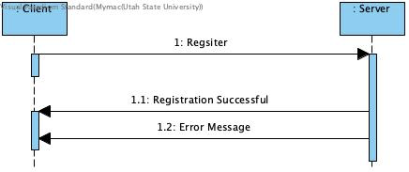

1. **Front End :**

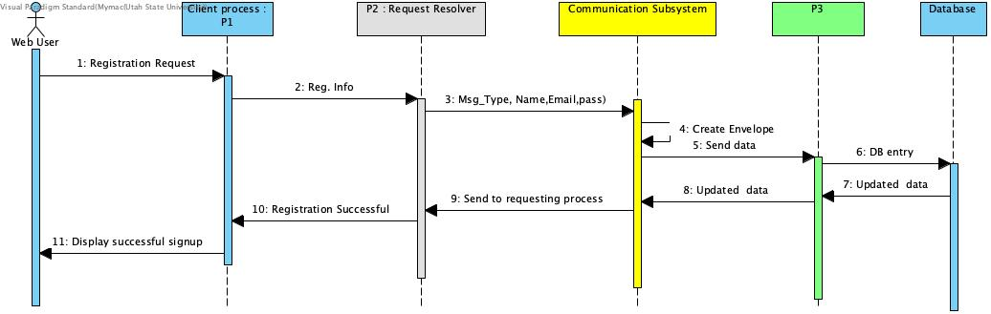

Request resolver will forward client request to other servers according to message types.

1. **Publish - Subscribe**

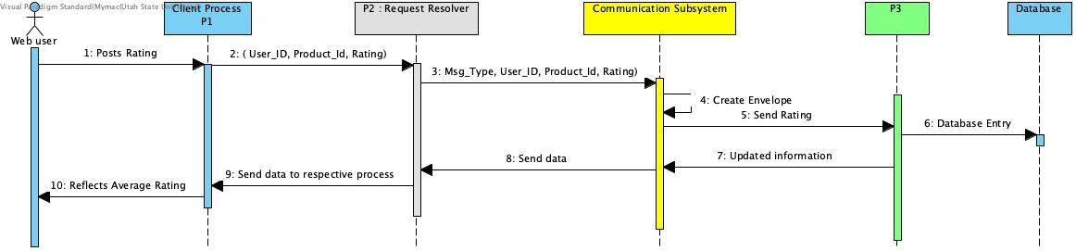

# **4** **Communication Protocols**

*(Describe each protocol list in Section 1, including the allowed message sequences, semantics, and expected process behaviors)*

1. **Register**: A new user can register themselves by filling a registration form and confirming their Email address which will complete their registration.
2. **Login**: Registered users can log in using their Email-id/username and password.
3. **Search Product** : Users can search about a product they want to rate and know reviews about.
4. **Create Product** : Users may create a listing for any individual/product not already listed.

and share their experience with that product.

1. **Rate Product** : Registered users can give star rating (0 - 5) to a product and add some comments that would justify their rating.
2. **Add Comment**: Other users can add their comments on already given reviews.
3. **Follow Product**: Users can follow a product and get updates whenever someone adds a comment, review or star rates that product.
4. **Mark** **Helpful**: This is feedback service if people find a particularly helpful they can mark that review as helpful, just like a like button.
5. **Get Products Based on Interest**: The Registered user will be asked their product category preference on the basis of which the products will be suggested.

